THE DESIGNS DOCUMENT

Designs Document

**Project:** ECSE211 Project Fall 2019

**Task**: Showcase and document every hardware design or ideas for the robot and its components

**Document Version Number**: 1.1

**Date:** 10/19/19

**Author:** Tony Ou

**Edit History:**

|  |  |  |  |
| --- | --- | --- | --- |
| *Version Number* | *Date* | *Author* | *Description* |
| *Version 1.1* | *Oct 19th, 2019* | *Tony Ou* | *Initial Designs* |

Robot design 1

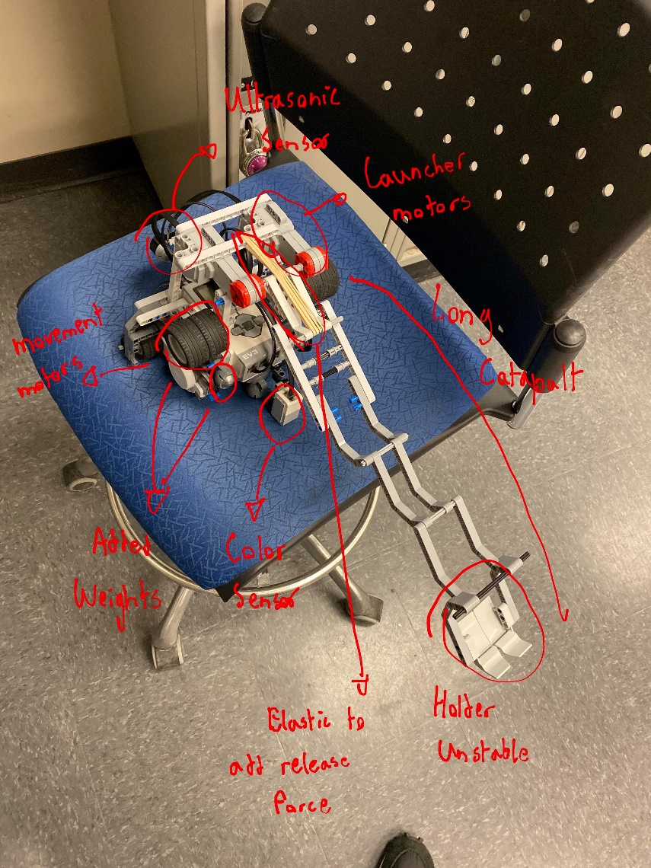

Strengths:

* Long range, can reach 4 tiles
* Stable base

Weaknesses:

* Massive size
* Unstable launcher
* Launches not consistent
* Hard to reach display
* Heavy launcher, hard to pull up

Robot design 2

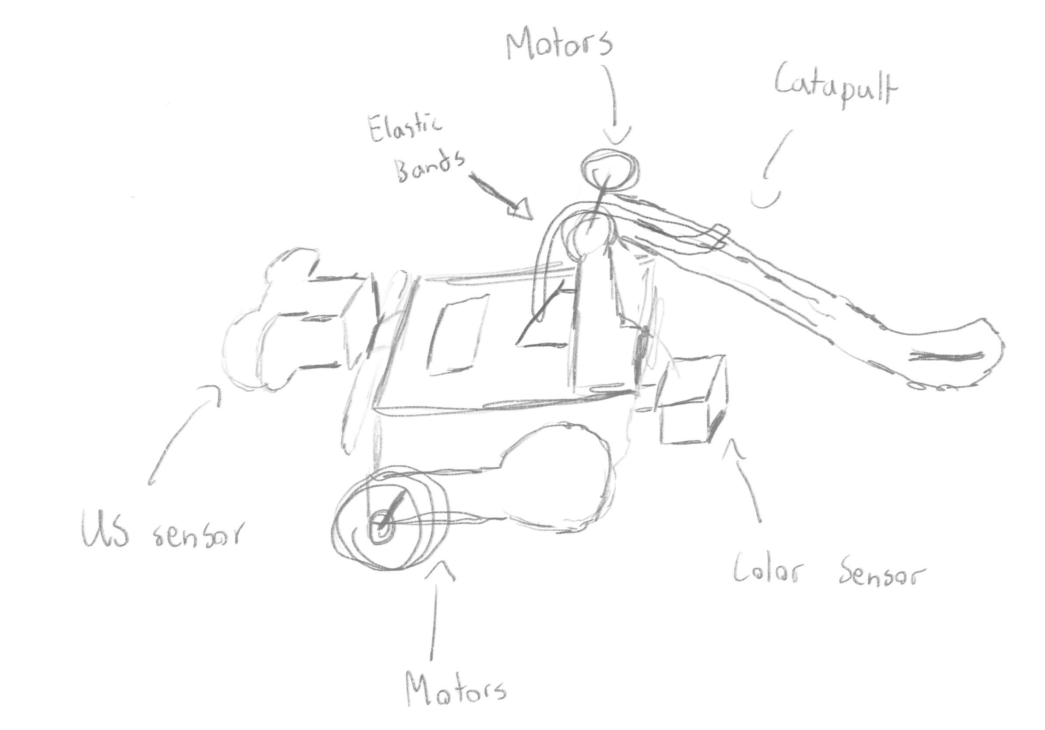

Strengths:

* Open display
* Utilizes less pieces
* Simple and easy to reproduce

Weaknesses:

* Unstable motor placement
* Small range (Currently 2 tiles max)

Robot design 3

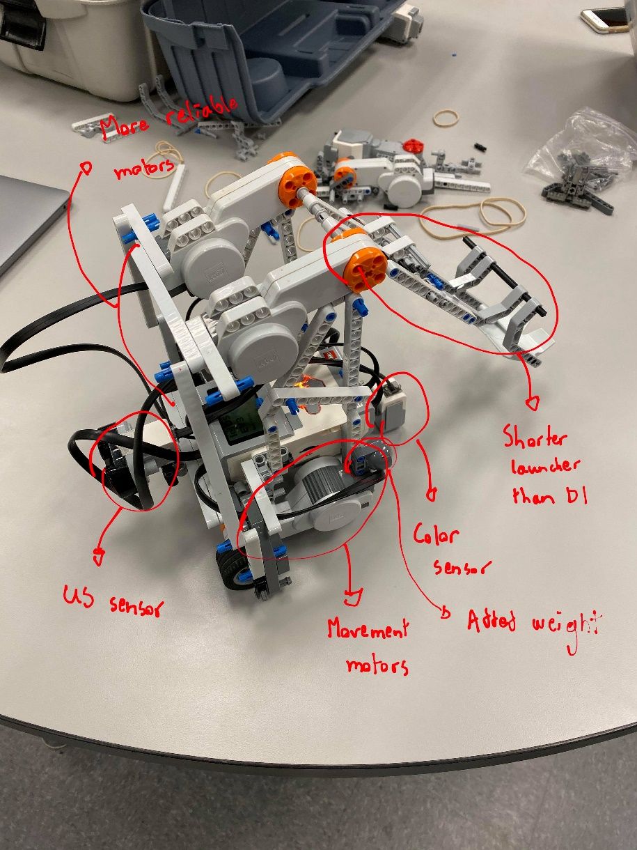

Strengths:

* Same long range as design 1 with smaller launcher and no elastic bands
* Easily accessible display
* Less weights than design 1
* Stable launches

Weaknesses:

* Fragile structure

Component design 1

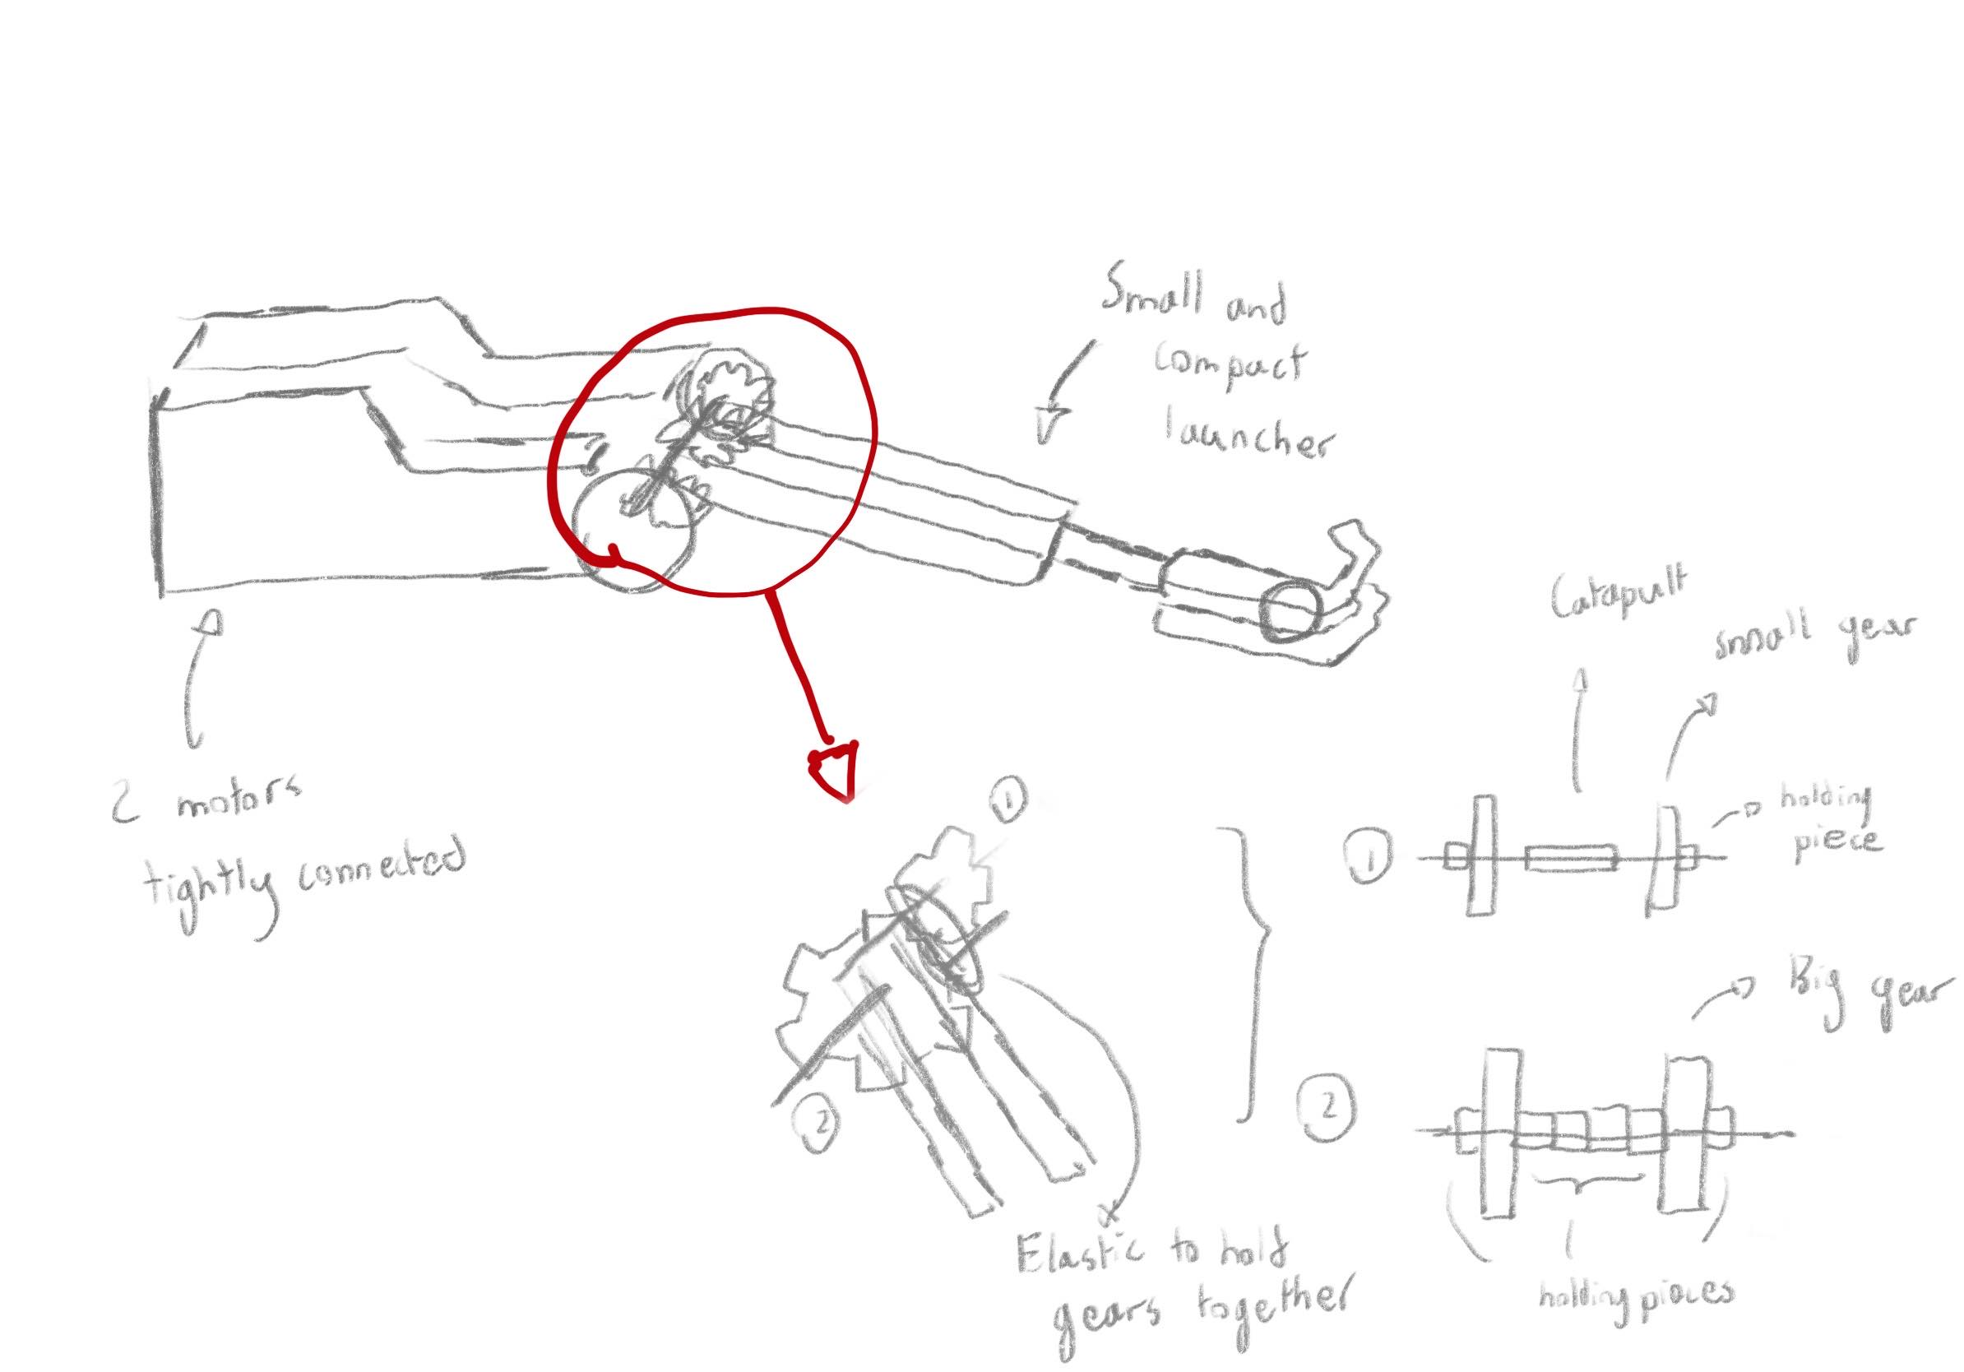

Strengths:

* Compact launcher system size
* Powerful launches without elastic bands
* Stable launches (no moving parts)
* Easy replacement of launcher

Weaknesses:

* Unreliability of the gears, often not hold tight enough during launches